Sashin Smith

[Email address]

Information

It contains my code for the project and screenshots relating to the code

JavaScript Exam

First Website with JavaScript

Table of Contents

JavaScript code 2

Implementation of coding – Date Object 2

Implementation of code – Images 2

Implementation of code – Arrays to populate calendar 4

Implementation of code – Graphical User Interfaces elements 4

Implementation of coding – Validation of user input fields, try/catch error handling 6

Implementation of coding – Cookies 9

Implementation of code – Use of if, if/else, else if, switch or loop statement 15

Implementation of coding – Mathematical calculation to compute cost 18

Implementation of code – Event listener 19

Images 20

Home Page 20

Images rotate 20

Zoom 20

Create Promotion Page 21

Validation 22

Cookies 23

Sign-up Page 24

Validation 24

Cookies 24

Edit Promotion Page 25

Validation 26

Cookies 28

Delete Promotion Page 29

Promotion 1 Summary Page 30

Promotion 2 Summary Page 31

Promotion 3 Summary Page 32

Student’s Disciplinary Code Page 32

Sub Page 1 – Student’s Disciplinary Code 33

Sub Page 6 – Student’s Disciplinary Code Validation 33

Sub Page 9 – Student’s Disciplinary Code 34

Functions 34

Explanation 34

# JavaScript code

## Implementation of coding – Date Object

//adds calendar

function calendar() {

var dateObject = new Date();

var date;

var dateCells;

var numDays;

var dayOfWeek;

//stores all the months

var monthArr = ["Jan", "Feb", "Mar", "Apr", "May", "Jun", "Jul", "Aug", "Sep", "Oct", "Nov", "Dec"];

var year = dateObject.getFullYear;

var curMonth = monthArr[dateObject.getMonth()];

var dayOfWeek = dateObject.getDay();

dateObject.setDate(1);

if (curMonth === 0 || curMonth === 2 || curMonth === 4 || curMonth === 6 || curMonth === 7 || curMonth === 9 || curMonth === 11) {

numDays = 31;

} else if (curMonth === 1) {

if (year % 4 === 0) {

if (year % 100 === 0) {

if (year % 400 === 0) {

numDays = 29;

} else {

numDays = 28

}

} else {

numDays = 29;

}

} else {

numDays = 28;

}

} else {

numDays = 30;

}

dateCells = document.getElementsByTagName("td");

for (var i = 0; i < dateCells.length; i++) {

dateCells[i].innerHTML = "";

}

for (var i = 1; i < numDays+1; i++) {

dateCells[i].innerHTML = dateObject.getDate();

date = dateObject.getDate() + 1;

dateObject.setDate(date);

}

document.getElementById("monthCap").innerHTML = curMonth;

calendarProm();

}

## Implementation of code – Images

//photogallery code

var photoOrder = [1, 2, 3, 4, 5]; //array of photo order to keep track of which photo should be displayed

var figureCount = 3;

function setUpPage() {

createEventListeners();

populateFigures();

}

function createEventListeners() { //assigns the onclick function to the arrow

var leftarrow = document.getElementById("leftarrow");

if (leftarrow.addEventListener) {

leftarrow.addEventListener("click", leftArrow, false);

} else if (leftarrow.attachEvent) {

leftarrow.attachEvent("onclick", leftArrow);

}

var rightarrow = document.getElementById("rightarrow");//assigns the onclick function to the arrow

if (rightarrow.addEventListener) {

rightarrow.addEventListener("click", rightArrow, false);

} else if (rightarrow.attachEvent) {

rightarrow.attachEvent("onclick", rightArrow);

}

var mainFig = document.getElementsByTagName("img")[1]; //function for when the user clicks on image

if (mainfig.addEventListener) {

mainFig.addEventListener("click", zoomFig, false);

} else if (mainFig.attachEvent) {

mainFig.attachEvent("onclick", zoomFig);

}

}

function rightArrow() {

for (var i = 0; i < 5; i++) {

if ((photoOrder[i] + 1) === 6) { //changes the photo array so the images rotate in a slide

photoOrder[i] = 1;

} else {

photoOrder[i] += 1;

}

populateFigures();

}

}

function leftArrow() {

for (var i = 0; i < 5; i++) {

if ((photoOrder[i] - 1) === 0) {//changes the photo array so the images rotate in a slide

photoOrder[i] = 1;

} else {

photoOrder[i] -= 1;

}

populateFigures();

}

}

function zoomFig() { //opens a new page where the page will have the imaged zoomed

var zoomWindow = window.open("zoom.html", "zoomin", "width=960,height=600");

}

function populateFigures() { //adds the images to the slide show in the correct order

var filename;

var currentFig;

if (figureCount === 3) { //only three are on display at a time

for (var i = 1; i < 5; i++) {

filename = "image" + i + ".jpg";

currentFig = document.getElementsByTagName("img")[i - 1];

currentFig.src = filename;

}

} else {

for (var i = 0; 1 < 5; i++) {

filename = "image" + photoOrder[i] + ".jpg";

currentFig = document.getElementsByTagName("img")[i];

currentFig.src = filename;

}

}

}

//inside the zoom.js

if (window.addEventListener) {

window.addEventListener("load", setUpPage, false);

} else if (window.attachEvent) {

window.attachEvent("onload", setUpPage);

}

//sets the order

var photoOrderArray = window.opener.photoOrder;

var figFilename = "image" + photoOrderArray[2] + ".jpg";

// adds the image

function pageSetup() {

document.getElementsByTagName("img")[1].src = figFilename; // assign filename to img element

}

window.onload = pageSetup;

## Implementation of code – Arrays to populate calendar

var monthArr = ["Jan", "Feb", "Mar", "Apr", "May", "Jun", "Jul", "Aug", "Sep", "Oct", "Nov", "Dec"];

## Implementation of code – Graphical User Interfaces elements

//adds link to the calendar to sign-up for promotion

function calendarProm() {

//get all td elements

var dateCells = document.getElementsByTagName("td");

//get data from cookie to read

var cookieString = document.cookie;

var cookieArray = cookieString.split("; ");

//regular expression to check if the value in the cookie array matches

var cookiePattern = /^(date=)/;

//for loop to add links to the calendar

for (var i = 0; i < cookieArray.length; i++) {

if (cookiePattern.test(cookieArray[i]) === true) {

//gets the date of the promotion

var dateAdd = cookieArray[i];

dateAdd = dateAdd.slice(13, 16);

//adds the link to calendar

for (var i = 0; i < dateCells.length; i++) {

if (dateCells[i].innerHTML === dateAdd) {

var testItem = dateCells[i]

var newLink = document.createElement("a");

var linkText = document.createTextNode(dateCells[i].innerHTML)

dateCells[i].innerHTML = "";

newLink.appendChild(linkText);

newLink.title = dateCells[i].innerHTML;

newLink.href = "scbeauty_signprom.html";

testItem.appendChild(newLink);

}

}

}

}

}

//clear function to remove all inputs

function removeSelectDefaults() {

//works with the clear button

document.getElementById("myForm1").reset();

document.getElementById("myForm2").reset();

document.getElementById("myForm3").reset();

document.getElementById("myForm4").reset();

}

//check password

function passwordCheck() {

var password = window.prompt("Please enter password.", "");

if (password = "ilovehair") {

editForm();

} else {

alert("Password is incorrect");

}

} //end of function

//check password

function passwordCheck1() {

var password = window.prompt("Please enter password.", "");

if (password = "ilovehair") {

window.open("delete.html");;

} else {

alert("Password is incorrect");

}

} //end of function

function openSum() {

window.open("summary.html");

}

function confirmNext(evt) {

var checkBox = document.getElementsByTagName("input");

var item;

for (var i = 0; i < checkBox.length; i++) {

item = document.getElementById("c" + i);

if (item.checked === false) {

allvalid = false;

}

}

var ans = confirm("Have you read all the information?");

if (allvalid !== true ) {

evt.preventDefault();

} else if (ans !== true) {

evt.preventDefault();

}

}

function changeSelect() {

var sel = document.getElementById("prom");//gets the selected promotion value

var current = sel.selectedIndex;//gets the current selected index

//hides ones that are not available

var selM = document.getElementById("menue");

if (arrTea[current] === "true") {

var opt = document.createElement("option");

opt.appendChild(document.createTextNode("tea"));//adds the array value to the option

opt.value = 'tea';

selM.appendChild(opt);//adds the value to the option

}

if (arrCoffee[current] === "true") {

var opt = document.createElement("option");

opt.appendChild(document.createTextNode("coffee"));//adds the array value to the option

opt.value = 'coffee';

selM.appendChild(opt);//adds the value to the option

}

if (arrSandwitches[current] === "true") {

var opt = document.createElement("option");

opt.appendChild(document.createTextNode("sandwitches"));//adds the array value to the option

opt.value = 'sandwitches';

selM.appendChild(opt);//adds the value to the option

}

if (arrBiscuits[current] === "true") {

var opt = document.createElement("option");

opt.appendChild(document.createTextNode("biscuits"));//adds the array value to the option

opt.value = 'biscuits';

selM.appendChild(opt);//adds the value to the option

}

}

## Implementation of coding – Validation of user input fields, try/catch error handling

//validate form 4

function validateForm4() {

//get all input to be validated

var number = document.getElementById("Cnum").value;

var email = document.getElementById("Cemail").value;

var name = document.getElementById("Cname").value;

//get error fields and reset them

var messN = document.getElementById("messN");

messN.innerHTML = "";

var messE = document.getElementById("messE");

messE.innerHTML = "";

var messNa = document.getElementById("messNa");

messNa.innerHTML = "";

//regular expression to test email

var emailPattern = /^\w+([\.-]?\w+)*@\w+([\.-]?\w+)*(\.\w{2,3})+$/;

//tests if the name input is blank

try {

if (name === "") throw "Please enter a name";

}

catch (err) {

messNa.innerHTML = err;

allVallid = false;

}

//try statements to test if number is a number and correct length

try {

if (isNaN(number) === true || number.length < 10 || number==="") throw "Please enter your number in plain format. eg 0213334567";

}

catch (err) {

messN.innerHTML = err;

allVallid = false;

}

//try statement to test if email is valid

try {

if (emailPattern.test(email) === false) throw "Please enter a valid email";

}

catch (err) {

messE.innerHTML = err;

allVallid = false;

}

if (allVallid === true && makeCookie === true) {

createCookie();

}

}

//validates form 3

function validateForm3() {

var menueArr = document.getElementsByName("menue");

var priceArr = document.getElementsByName("priceM");

var messM = document.getElementById("messM0");

messM.innerHTML = "";

messM = document.getElementById("messM1");

messM.innerHTML = "";

messM = document.getElementById("messM2");

messM.innerHTML = "";

messM = document.getElementById("messM3");

messM.innerHTML = "";

//checks if the menue item is checked

//if checked it will test the value of the corresponding price

try {

if (menueArr[0].checked) {

if (priceArr[0].value < 0 || isNaN(priceArr[0].value) === true) {

messM = document.getElementById("messM0");

throw "Please enter the price as a number";

}

}

if (menueArr[1].checked) {

if (priceArr[1].value < 0 || isNaN(priceArr[1].value) === true) {

messM = document.getElementById("messM1");

throw "Please enter the price as a number";

}

}

if (menueArr[2].checked) {

if (priceArr[2].value < 0 || isNaN(priceArr[2].value) === true) {

messM = document.getElementById("messM2");

throw "Please enter the price as a number";

}

}

if (menueArr[3].checked) {

if (priceArr[3].value < 0 || isNaN(priceArr[3].value) === true) {

messM = document.getElementById("messM3");

throw "Please enter the price as a number";

}

}

}

catch (err) {

messM.innerHTML = err;

allVallid = false;

}

validateForm4();

}

//validates form 2

function validateForm2() {

var price = document.getElementById("price").value;

//get the error fields and reset them

var messS = document.getElementById("messS");

messS.innerHTML = "";

var messP = document.getElementById("messP");

messP.innerHTML = "";

//checks if a service has been checked

try {

if (!(document.getElementById("service1").checked || document.getElementById("service2").checked || document.getElementById("service3").checked)) throw "Please select a service";

}

catch (err) {

messS.innerHTML = err;

allVallid = false;

}

//checks if the price is a number and positive

try {

if (isNaN(price) === true) throw "Please enter a number";

if (price < 0) throw "Please enter a positive whole number";

}

catch (err) {

messP.innerHTML = err;

allVallid = false

}

validateForm3();

}

function validateForm1() {

//reset the allvalid variable so that it can validate everything from begining

allVallid = true;

//get all input of the first form

var Pname = document.getElementById("Pname").value;

var Ptime = document.getElementById("Ptime").value;

var Pdate = document.getElementById("Pdate").value;

var duration = document.getElementsByName("duration");

//get all error fields where errors will be displayed

var messT = document.getElementById("messT");

messT.innerHTML = "";//removes previous error

var messD = document.getElementById("messD");

messD.innerHTML = "";

var messDu = document.getElementById("messDu");

messDu.innerHTML = "";

var messPN = document.getElementById("messPN");

messPN.innerHTML = "";

//validate promotion name

try {

if (Pname === "" || Pname === null) throw "Please enter a promotion name";

}

catch (err) {

messPN.innerHTML = err;

allVallid = false;

}

//validate time

//regular expression for the time pattern

//checks if the time is in the 24 hour margin

var timePattern = /^(0[0-9]|1[0-9]|2[0-3]):[0-5][0-9]$/;

try {

if (Ptime === "") throw "Please enter a time";

if (isNaN(Ptime.substring(0, 2)) === true || isNaN(Ptime.substring(3, 5)) === true) throw "Please enter the time as a number";

if (timePattern.test(Ptime) === false) throw "Please enter the time in the correct format HH:MM";

}

catch (err) {

messT.innerHTML = err;

allVallid = false;

}

//validate date

try {

//divides the input in the correct sections

var year = Pdate.substring(0, 4);

var month = Pdate.substring(5, 7);

var day = Pdate.substring(8, 10);

//checks if the characters are all numbers

if (isNaN(year) === true || isNaN(month) === true || isNaN(day) === true) throw "The date has to be in numbers";

//checks if the month does not exceed 12

if (month > 12 || month < 1) throw "The month needs to be between 1-12";

month = parseInt(month);

day = parseInt(day);

//switch statement to check if the month has the correct number of days

switch (month) {

case 1: case 3: case 5: case 7: case 8: case 10: case 12:

if (day > 31) throw "Please enter a correct number of days";

break;

case 4: case 6: case 9: case 11:

if (day > 30) throw "There cannot be more than 30 days in this month";

break;

case 2:

//checks if the current year is a leap year and checks if the days do not exceed the limit

if (year % 4 === 0) {

if (year % 100 === 0) {

if (year % 400 === 0) {

if (day > 29) throw "There cannot be more than 29 days in this month";

} else {

if (day > 28) throw "There cannot be more than 28 days in this month";

}

} else {

if (day > 29) throw "There cannot be more than 29 days in this month";

}

} else {

if (day > 28) throw "There cannot be more than 28 days in this month";

}

break;

}

//checks if the date selected is in the past

var selectDate = new Date(Pdate);

var dateToday = new Date();

if (selectDate < dateToday) throw "This date cannot be in past";

}

catch (err) {

messD.innerHTML = err;

allVallid = false;

}

//validates if a duration has been selected

try {

if (!(document.getElementById("duration1").checked || document.getElementById("duration2").checked || document.getElementById("duration3").checked)) throw "Please select a duration";

}

catch (err) {

messDu.innerHTML = err;

allVallid = false;

}

validateForm2();

}

## Implementation of coding – Cookies

//adds in promotion as a cookie

function createCookie() {

alert("running")

//get all input

//form1

var Pname = document.getElementById("Pname").value;

var message = document.getElementById("message").value;

var Ptime = document.getElementById("Ptime").value;

var Pdate = document.getElementById("Pdate").value;

var duration = document.getElementById("duration1");

if (duration.checked === true) {

duration = duration.value;

} else {

var duration = document.getElementById("duration2");

if (duration.checked === true) {

duration = duration.value;

} else {

var duration = document.getElementById("duration3");

if (duration.checked === true) {

duration = duration.value;

}

}

}

var Pvenue = document.getElementById("Pvenue").value;

var Pprom = document.getElementById("Pprom").value;

//form2

var service = document.getElementById("service1");

if (service.checked === true) {

service = service.value;

} else {

service = document.getElementById("service2");

if (service.checked === true) {

service = service.value;

} else {

service = document.getElementById("service3");

if (service.checked === true) {

service = service.value;

}

}

}

var price = document.getElementById("price").value;

//form3

var menueArr = document.getElementsByName("menue");

var priceArr = document.getElementsByName("priceM");

var holdMarr = new Array();

var holdParr = new Array();

for (var i = 0; i < menueArr.length; i++) {

if (menueArr[i].checked) {

holdMarr.push(true);

holdParr.push(priceArr[i].value);

} else {

holdMarr.push(false);

holdParr.push("none");

}

}

//form4

var name = document.getElementById("Cname").value;

var number = document.getElementById("Cnum").value;

var email = document.getElementById("Cemail").value;

//set the expire date of cookie

//converts into the time date format

var holdDate = Pdate.substring(8, 10);

holdDate = parseInt(holdDate);

//adds the duration to the date

holdDate += parseInt(duration);

//converts back to a string to work correctly in the date

holdDate = holdDate.toString();

//adds a 0 if it is less than 10

if (holdDate.length < 2) {

holdDate = "0" + holdDate;

}

//converts into the date format

var myDate = (Pdate.substring(0, 4)) + "-" + Pdate.substring(5, 7) + "-" + holdDate + "T" + (Ptime.substring(0, 2)) + ":" + (Ptime.substring(3, 5)) + ":" + "00Z";

var selectDate = new Date(myDate);

var expires = "expires=" + selectDate.toUTCString();

//add all information to cookie

document.cookie = "promName=" + Pname + "; expires=" + expires + "; path=/";

document.cookie = "message=" + message + "; expires=" + expires + "; path=/";

document.cookie = "time=" + Ptime + "; expires=" + expires + "; path=/";

document.cookie = "date=" + Pdate + "; expires=" + expires + "; path=/";

document.cookie = "duration=" + duration + "; expires=" + expires + "; path=/";

document.cookie = "venue=" + Pvenue + "; expires=" + expires + "; path=/";

document.cookie = "promotion=" + Pprom + "; expires=" + expires + "; path=/";

document.cookie = "service=" + service + "; expires=" + expires + "; path=/";

document.cookie = "price=" + price + "; expires=" + expires + "; path=/";

document.cookie = "tea=" + holdMarr[0] + "; expires=" + expires + "; path=/";

document.cookie = "priceT=" + holdParr[0] + "; expires=" + expires + "; path=/";

document.cookie = "coffee=" + holdMarr[1] + "; expires=" + expires + "; path=/";

document.cookie = "priceC=" + holdParr[1] + "; expires=" + expires + "; path=/";

document.cookie = "sandwitches=" + holdMarr[2] + "; expires=" + expires + "; path=/";

document.cookie = "priceS=" + holdParr[2] + "; expires=" + expires + "; path=/";

document.cookie = "biscuits=" + holdMarr[3] + "; expires=" + expires + "; path=/";

document.cookie = "priceB=" + holdParr[3] + "; expires=" + expires + "; path=/";

document.cookie = "conName=" + name + "; expires=" + expires + "; path=/";

document.cookie = "conNumber=" + number + "; expires=" + expires + "; path=/";

document.cookie = "conEmail=" + email + "; expires=" + expires + "; path=/";

}

//function to open edit form

function editForm() {

makeCookie = false;

var cookieString = document.cookie;

var cookieArray = cookieString.split("; ");

var holdItem;//holds the position of the =

var holdLength;//holds the length of the item

//regular expressions to determine what data the current item is

var promNamePattern = /^(promName=)/;

var messPattern = /^(message=)/;

var timePattern = /^(time=)/;

var datePattern = /^(date=)/;

var durPattern = /^(duration=)/;

var venuePattern = /^(venue=)/;

var promPattern = /^(promotion=)/;

var servPattern = /^(service=)/;

var pricePattern = /^(price=)/;

var teaPattern = /^(tea=)/;

var pTPattern = /^(priceT=)/;

var coffPattern = /^(coffee=)/;

var pCPattern = /^(priceC=)/;

var sandPattern = /^(sandwitches=)/;

var pSPattern = /^(priceS=)/;

var bisPattern = /^(biscuits=)/;

var pBPattern = /^(priceB=)/;

var conNamePattern = /^(conName=)/;

var conNumPattern = /^(conNumber=)/;

var conEmailPattern = /^(conEmail=)/;

//for loop that adds all cookie information to the arrays for holding

for (var i = 0; i < cookieArray.length; i++) {

holdItem = cookieArray[i].search("=");

holdLength = cookieArray[i].length;

holdItem = cookieArray[i].slice(holdItem + 1, holdLength);

//checks what the item is what and adds to correct array

if (promNamePattern.test(cookieArray[i]) === true) {

arrPromName.push(holdItem);

}

if (messPattern.test(cookieArray[i]) === true) {

arrMessage.push(holdItem);

}

if (timePattern.test(cookieArray[i]) === true) {

arrTime.push(holdItem);

}

if (datePattern.test(cookieArray[i]) === true) {

arrDate.push(holdItem);

}

if (durPattern.test(cookieArray[i]) === true) {

arrDur.push(holdItem);

}

if (venuePattern.test(cookieArray[i]) === true) {

arrVenue.push(holdItem);

}

if (promPattern.test(cookieArray[i]) === true) {

arrProm.push(holdItem);

}

if (servPattern.test(cookieArray[i]) === true) {

arrService.push(holdItem);

}

if (pricePattern.test(cookieArray[i]) === true) {

arrPrice.push(holdItem);

}

if (teaPattern.test(cookieArray[i]) === true) {

arrTea.push(holdItem);

}

if (pTPattern.test(cookieArray[i]) === true) {

arrPriceT.push(holdItem);

}

if (coffPattern.test(cookieArray[i]) === true) {

arrCoffee.push(holdItem);

}

if (pCPattern.test(cookieArray[i]) === true) {

arrPriceC.push(holdItem);

}

if (sandPattern.test(cookieArray[i]) === true) {

arrSandwitches.push(holdItem);

}

if (pSPattern.test(cookieArray[i]) === true) {

arrPriceS.push(holdItem);

}

if (bisPattern.test(cookieArray[i]) === true) {

arrBiscuits.push(holdItem);

}

if (pBPattern.test(cookieArray[i]) === true) {

arrPriceB.push(holdItem);

}

if (conNamePattern.test(cookieArray[i]) === true) {

arrConName.push(holdItem);

}

if (conNumPattern.test(cookieArray[i]) === true) {

arrConNum.push(holdItem);

}

if (conEmailPattern.test(cookieArray[i]) === true) {

arrConEmail.push(holdItem);

}

}

promOption();

}

function deleteCookie() {

//alert to warn user

alert("Warning information will be deleted");

//get all input

//form1

var Pname = document.getElementById("Pname").value;

var message = document.getElementById("message").value;

var Ptime = document.getElementById("Ptime").value;

var Pdate = document.getElementById("Pdate").value;

var duration = document.getElementById("duration1");

if (duration.checked === true) {

duration = duration.value;

} else {

var duration = document.getElementById("duration2");

if (duration.checked === true) {

duration = duration.value;

} else {

var duration = document.getElementById("duration3");

if (duration.checked === true) {

duration = duration.value;

}

}

}

var Pvenue = document.getElementById("Pvenue").value;

var Pprom = document.getElementById("Pprom").value;

//form2

var service = document.getElementById("service1");

if (service.checked === true) {

service = service.value;

} else {

service = document.getElementById("service2");

if (service.checked === true) {

service = service.value;

} else {

service = document.getElementById("service3");

if (service.checked === true) {

service = service.value;

}

}

}

var price = document.getElementById("price").value;

//form3

var menueArr = document.getElementsByName("menue");

var priceArr = document.getElementsByName("priceM");

var holdMarr = new Array();

var holdParr = new Array();

for (var i = 0; i < menueArr.length; i++) {

if (menueArr[i].checked) {

holdMarr.push(true);

holdParr.push(priceArr[i].value);

} else {

holdMarr.push(false);

holdParr.push("none");

}

}

//form4

var name = document.getElementById("Cname").value;

var number = document.getElementById("Cnum").value;

var email = document.getElementById("Cemail").value;

//set the expire date of cookie

var expires = new Date(-7);

//add all information to cookie

document.cookie = "promName=" + Pname + "; expires=" + expires + "; path=/";

document.cookie = "message=" + message + "; expires=" + expires + "; path=/";

document.cookie = "time=" + Ptime + "; expires=" + expires + "; path=/";

document.cookie = "date=" + Pdate + "; expires=" + expires + "; path=/";

document.cookie = "duration=" + duration + "; expires=" + expires + "; path=/";

document.cookie = "venue=" + Pvenue + "; expires=" + expires + "; path=/";

document.cookie = "promotion=" + Pprom + "; expires=" + expires + "; path=/";

document.cookie = "service=" + service + "; expires=" + expires + "; path=/";

document.cookie = "price=" + price + "; expires=" + expires + "; path=/";

document.cookie = "tea=" + holdMarr[0] + "; expires=" + expires + "; path=/";

document.cookie = "priceT=" + holdParr[0] + "; expires=" + expires + "; path=/";

document.cookie = "coffee=" + holdMarr[1] + "; expires=" + expires + "; path=/";

document.cookie = "priceC=" + holdParr[1] + "; expires=" + expires + "; path=/";

document.cookie = "sandwitches=" + holdMarr[2] + "; expires=" + expires + "; path=/";

document.cookie = "priceS=" + holdParr[2] + "; expires=" + expires + "; path=/";

document.cookie = "biscuits=" + holdMarr[3] + "; expires=" + expires + "; path=/";

document.cookie = "priceB=" + holdParr[3] + "; expires=" + expires + "; path=/";

document.cookie = "conName=" + name + "; expires=" + expires + "; path=/";

document.cookie = "conNumber=" + number + "; expires=" + expires + "; path=/";

document.cookie = "conEmail=" + email + "; expires=" + expires + "; path=/";

removeSelectDefaults();

}

function portCookie() {

var cookieString = document.cookie;

var cookieArray = cookieString.split("; ");

var holdItem;//holds the position of the =

var holdLength;//holds the length of the item

//regular expressions to determine what data the current item is

var promNamePattern = /^(promName=)/;

var teaPattern = /^(tea=)/;

var coffPattern = /^(coffee=)/;

var sandPattern = /^(sandwitches=)/;

var bisPattern = /^(biscuits=)/;

for (var i = 0; i < cookieArray.length; i++) {

holdItem = cookieArray[i].search("=");

holdLength = cookieArray[i].length;

holdItem = cookieArray[i].slice(holdItem + 1, holdLength);

//checks what the item is what and adds to correct array

if (promNamePattern.test(cookieArray[i]) === true) {

arrPromName.push(holdItem);

}

if (teaPattern.test(cookieArray[i]) === true) {

arrTea.push(holdItem);

}

if (coffPattern.test(cookieArray[i]) === true) {

arrCoffee.push(holdItem);

}

if (sandPattern.test(cookieArray[i]) === true) {

arrSandwitches.push(holdItem);

}

if (bisPattern.test(cookieArray[i]) === true) {

arrBiscuits.push(holdItem);

}

}

promOption();

}

//creates a cookies for attendees

function createCookieAtt() {

var sel = document.getElementById("prom");//gets the selected promotion value

var current = sel.selectedIndex;//gets the current selected index

document.cookie = "attProm=" + current;

document.cookie = "attName=" + document.getElementById("Cname").value;

document.cookie = "attNum=" + document.getElementById("Cemail").value;

document.cookie = "attEmail=" + document.getElementById("Cemail").value;

sel = document.getElementById("menue");//gets the selected promotion value

current = sel.selectedIndex;//gets the current selected index

document.cookie = "attMenue=" + current;

document.cookie = "attCom=" + document.getElementById("comment").value;

}

//adds the attendee info to array

function attendeesAdd() {

var cookieString = document.cookie;

var cookieArray = cookieString.split("; ");

var hold = document.getElementById("prom");

var current = hold.selectedIndex;//gets current promotion in view

var holdItem;//holds the temporary value

var holdLength;

for (var i = 0; i < cookieArray.length; i++) {

if (cookieArray[i] === "attProm=" + current) {

holdItem = cookieArray[i+1].search("=");

holdLength = cookieArray[i+1].length;

holdItem = cookieArray[i + 1].slice(holdItem + 1, holdLength);

arrAtt.push(holdItem)

holdItem = cookieArray[i + 2].search("=");

holdLength = cookieArray[i + 2].length;

holdItem = cookieArray[i + 2].slice(holdItem + 1, holdLength);

arrAttMenue.push(holdItem)

holdItem = cookieArray[i + 3].search("=");

holdLength = cookieArray[i + 3].length;

holdItem = cookieArray[i + 3].slice(holdItem + 1, holdLength);

arrAttPrice.push(holdItem)

}

}

}

## Implementation of code – Use of if, if/else, else if, switch or loop statement

//adds the promotions to a select with options

function promOption() {

//creates new options for each promotion

var sel = document.getElementById("prom");//gets the select

for (var i = 0; i < arrPromName.length; i++) {

var opt = document.createElement("option");

opt.appendChild(document.createTextNode(arrPromName[i]));//adds the array value to the option

opt.value = 'option value';

sel.appendChild(opt);//adds the value to the option

}

changeSelect();//adds the data for the promotion that the user wants to look at

sel.addEventListener("change", changeSelect);//runs every time the user changes the promotion

}//end of function

//function to add all information to form

function changeSelect() {

var sel = document.getElementById("prom");//gets the selected promotion value

current = sel.selectedIndex;//gets the

//changes the form to the selected promotions data

document.getElementById("Pname").value = arrPromName[current];

document.getElementById("message").value = arrMessage[current];

document.getElementById("Ptime").value = arrTime[current];

document.getElementById("Pdate").value = arrDate[current];

switch (arrDur[current]) {

case ("1"):

document.getElementById("duration1").checked = true;

break;

case ("2"):

document.getElementById("duration2").checked = true;

break;

case ("3"):

document.getElementById("duration3").checked=true;

break;

}//allchecked

document.getElementById("Pvenue").value = arrVenue[current];

document.getElementById("Pprom").value = arrProm[current];

switch (arrService[current]) {

case ("colour"):

document.getElementById("service1").checked = true;

break;

case ("massage"):

document.getElementById("service2").checked = true;

break;

case ("waxing"):

document.getElementById("service3").checked = true;

break;

}//allchecked

document.getElementById("price").value = arrPrice[current];

if (arrTea[current] === "true") {

document.getElementById("priceM1").value = arrPriceT[current];

document.getElementById("tea").checked = true;

} else {

document.getElementById("tea").checked = false;

}

if (arrCoffee[current] === "true") {

document.getElementById("priceM2").value = arrPriceC[current];

document.getElementById("coffee").checked = true;

} else {

document.getElementById("coffee").checked = false;

}

if (arrSandwitches[current] === "true") {

document.getElementById("priceM3").value = arrPriceS[current];

document.getElementById("sand").checked = true;

} else {

document.getElementById("sand").checked = false;

}

if (arrBiscuits[current] === "true") {

document.getElementById("priceM4").value = arrPriceB[current];

document.getElementById("biscuits").checked = true;

} else {

document.getElementById("biscuits").checked = false;

}

document.getElementById("Cname").value = arrConName[current];

document.getElementById("Cnum").value = arrConNum[current];

document.getElementById("Cemail").value = arrConEmail[current];

makeCookie = true;

}//end of function

//function to open edit form

function deleteForm() {

makeCookie = false;

var cookieString = document.cookie;

var cookieArray = cookieString.split("; ");

var holdItem;//holds the position of the =

var holdLength;//holds the length of the item

//regular expressions to determine what data the current item is

var promNamePattern = /^(promName=)/;

var messPattern = /^(message=)/;

var timePattern = /^(time=)/;

var datePattern = /^(date=)/;

var durPattern = /^(duration=)/;

var venuePattern = /^(venue=)/;

var promPattern = /^(promotion=)/;

var servPattern = /^(service=)/;

var pricePattern = /^(price=)/;

var teaPattern = /^(tea=)/;

var pTPattern = /^(priceT=)/;

var coffPattern = /^(coffee=)/;

var pCPattern = /^(priceC=)/;

var sandPattern = /^(sandwitches=)/;

var pSPattern = /^(priceS=)/;

var bisPattern = /^(biscuits=)/;

var pBPattern = /^(priceB=)/;

var conNamePattern = /^(conName=)/;

var conNumPattern = /^(conNumber=)/;

var conEmailPattern = /^(conEmail=)/;

//for loop that adds all cookie information to the arrays for holding

for (var i = 0; i < cookieArray.length; i++) {

holdItem = cookieArray[i].search("=");

holdLength = cookieArray[i].length;

holdItem = cookieArray[i].slice(holdItem + 1, holdLength);

//checks what the item is what and adds to correct array

if (promNamePattern.test(cookieArray[i]) === true) {

arrPromName.push(holdItem);

}

if (messPattern.test(cookieArray[i]) === true) {

arrMessage.push(holdItem);

}

if (timePattern.test(cookieArray[i]) === true) {

arrTime.push(holdItem);

}

if (datePattern.test(cookieArray[i]) === true) {

arrDate.push(holdItem);

}

if (durPattern.test(cookieArray[i]) === true) {

arrDur.push(holdItem);

}

if (venuePattern.test(cookieArray[i]) === true) {

arrVenue.push(holdItem);

}

if (promPattern.test(cookieArray[i]) === true) {

arrProm.push(holdItem);

}

if (servPattern.test(cookieArray[i]) === true) {

arrService.push(holdItem);

}

if (pricePattern.test(cookieArray[i]) === true) {

arrPrice.push(holdItem);

}

if (teaPattern.test(cookieArray[i]) === true) {

arrTea.push(holdItem);

}

if (pTPattern.test(cookieArray[i]) === true) {

arrPriceT.push(holdItem);

}

if (coffPattern.test(cookieArray[i]) === true) {

arrCoffee.push(holdItem);

}

if (pCPattern.test(cookieArray[i]) === true) {

arrPriceC.push(holdItem);

}

if (sandPattern.test(cookieArray[i]) === true) {

arrSandwitches.push(holdItem);

}

if (pSPattern.test(cookieArray[i]) === true) {

arrPriceS.push(holdItem);

}

if (bisPattern.test(cookieArray[i]) === true) {

arrBiscuits.push(holdItem);

}

if (pBPattern.test(cookieArray[i]) === true) {

arrPriceB.push(holdItem);

}

if (conNamePattern.test(cookieArray[i]) === true) {

arrConName.push(holdItem);

}

if (conNumPattern.test(cookieArray[i]) === true) {

arrConNum.push(holdItem);

}

if (conEmailPattern.test(cookieArray[i]) === true) {

arrConEmail.push(holdItem);

}

}

promOption();

}

//adds information to the summary forms

function summaryAdd() {

var sel;

var i = document.getElementById("selProm").selectedIndex;

//details1

var sel = document.getElementById("line1");

sel.appendChild(document.createTextNode(arrMessage[i]));

sel = document.getElementById("line2");

sel.appendChild(document.createTextNode(arrTime[i]));

sel = document.getElementById("line3");

sel.appendChild(document.createTextNode(arrDate[i]));

sel = document.getElementById("line4");

sel.appendChild(document.createTextNode(arrDur[i]));

sel = document.getElementById("line5");

sel.appendChild(document.createTextNode(arrVenue[i]));

sel = document.getElementById("line6");

sel.appendChild(document.createTextNode(arrProm[i]));

sel = document.getElementById("line7");

sel.appendChild(document.createTextNode(arrService[i]));

sel = document.getElementById("line8");

sel.appendChild(document.createTextNode(arrPrice[i]));

total = arrPrice[i]//adds the price of promotion to total

if (arrTea[i] === "true") {

sel = document.getElementById("line9");

sel.appendChild(document.createTextNode("tea " + arrPriceT[i]));

}

if (arrCoffee[i] === "true") {

sel = document.getElementById("line9");

sel.appendChild(document.createTextNode("coffee " + arrPriceC[i]));

}

if (arrSandwitches[i] === "true") {

sel = document.getElementById("line9");

sel.appendChild(document.createTextNode("sandwitches " + arrPriceS[i]));

}

if (arrBiscuits[i] === "true") {

sel = document.getElementById("line9");

sel.appendChild(document.createTextNode("biscuits " + arrPriceB[i]));

}

sel = document.getElementById("line10");

sel.appendChild(document.createTextNode(arrConName[i] + " " + arrConNum[i] + " " + arrConEmail[i]));

//details2

attendeesAdd();

for (i = 0; i < arrAtt.length; i++) {

sel = document.getElementById("line"+11+i);

sel.appendChild(document.createTextNode(arrAtt[i]));

sel.appendChild(document.createTextNode(arrAttMenue[i]));

sel.appendChild(document.createTextNode(arrAttPrice[i]))

}

//details3

sel = document.getElementById("line20");

sel.appendChild(document.createTextNode(calculateTotal()));

}

## Implementation of coding – Mathematical calculation to compute cost

//calculates the total to be displayed

function calculateTotal() {

for (var i = 0; i < arrAttPrice.length; i++) {

total += arrAttPrice[i];

}

return total

}

## Implementation of code – Event listener

function createEventListeners() {

calendar();

//submit button

var btnSubmit = document.getElementById("submit");

if (btnSubmit.addEventListener) {

btnSubmit.addEventListener("click", validateForm1, false);

} else if (btnSubmit.attachEvent) {

btnSubmit.attachEvent("onclick", validateForm1);

}

//clear button

var btnReset = document.getElementById("reset");

if (btnReset.addEventListener) {

btnReset.addEventListener("click", removeSelectDefaults, false);

} else if (btnReset.attachEvent) {

btnReset.attachEvent("onclick", removeSelectDefaults);

}

//edit button

var btnEdit = document.getElementById("edit");

if (btnEdit.addEventListener) {

btnEdit.addEventListener("click", passwordCheck, false);

} else if (btnEdit.attachEvent) {

btnEdit.attachEvent("onclick", passwordCheck);

}

//delete button

var btnDelete = document.getElementById("delete");

if (btnDelete.addEventListener) {

btnDelete.addEventListener("click", passwordCheck1, false);

} else if (btnDelete.attachEvent) {

btnDelete.attachEvent("onclick", passwordCheck1);

}

//summary button

var btnSum = document.getElementById("btnSummary");

if (btnSum.addEventListener) {

btnSum.addEventListener("click", openSum, false);

} else if (btnSum.attachEvent) {

btnSum.attachEvent("onclick", openSum);

}

//next link

var btnNext = document.getElementById("next");

if (btnNext.addEventListener) {

btnNext.addEventListener("click", confirmNext, false);

} else if (btnNext.attachEvent) {

btnNext.attachEvent("onclick", confirmNext);

}

var btnSubmit = document.getElementById("submit");

if (btnSubmit.addEventListener) {

btnSubmit.addEventListener("click", deleteCookie, false);

} else if (btnSubmit.attachEvent) {

btnSubmit.attachEvent("onclick", deleteCookie);

}

}

if (window.addEventListener) {

window.addEventListener("load", createEventListeners, false);

} else if (window.attachEvent) {

window.attachEvent("onload", createEventListeners);

}

# Images

## Home Page

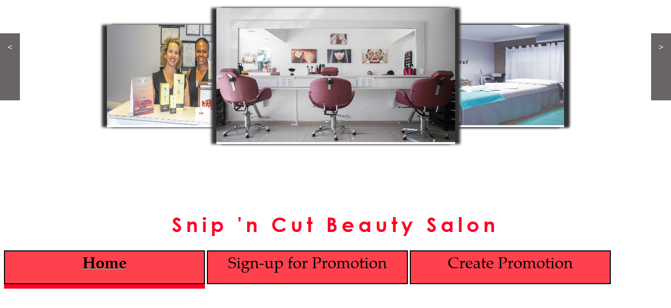

### Images rotate

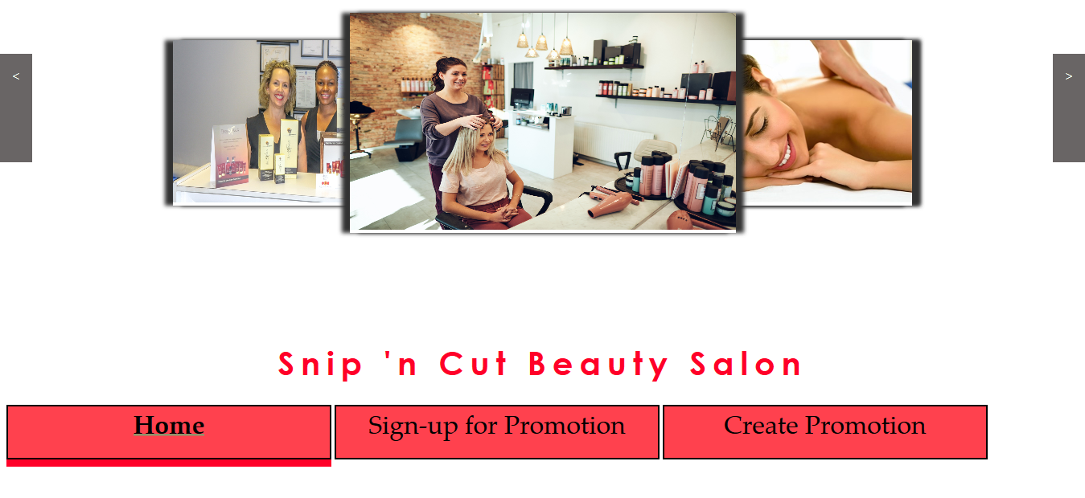

### Zoom

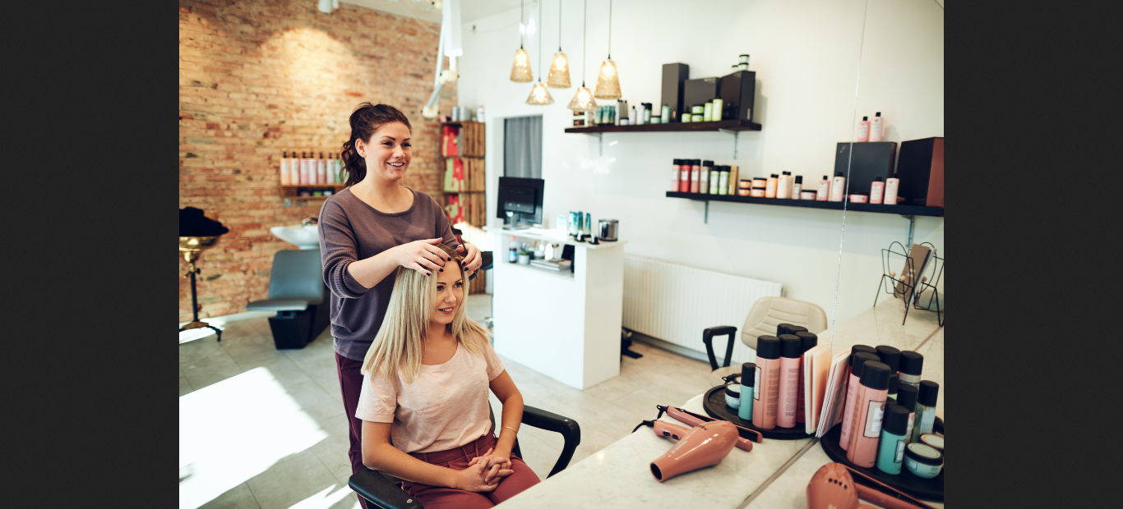

## Create Promotion Page

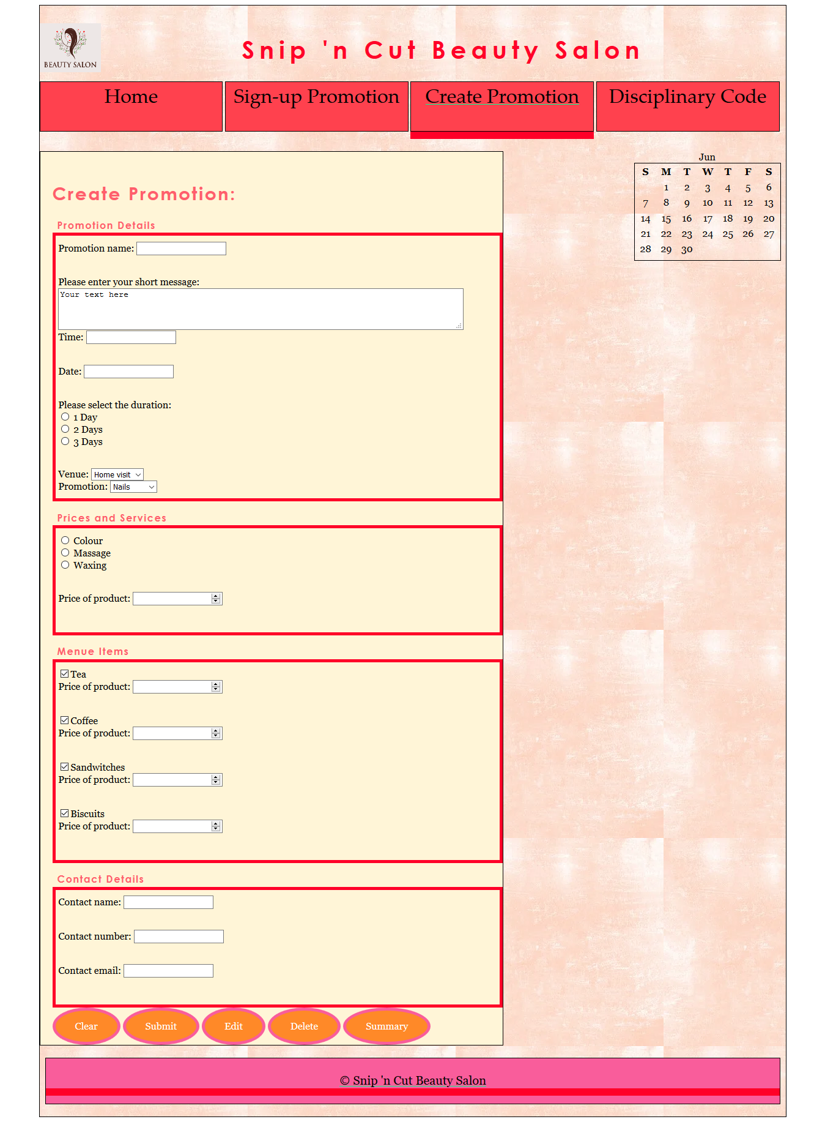

### Validation

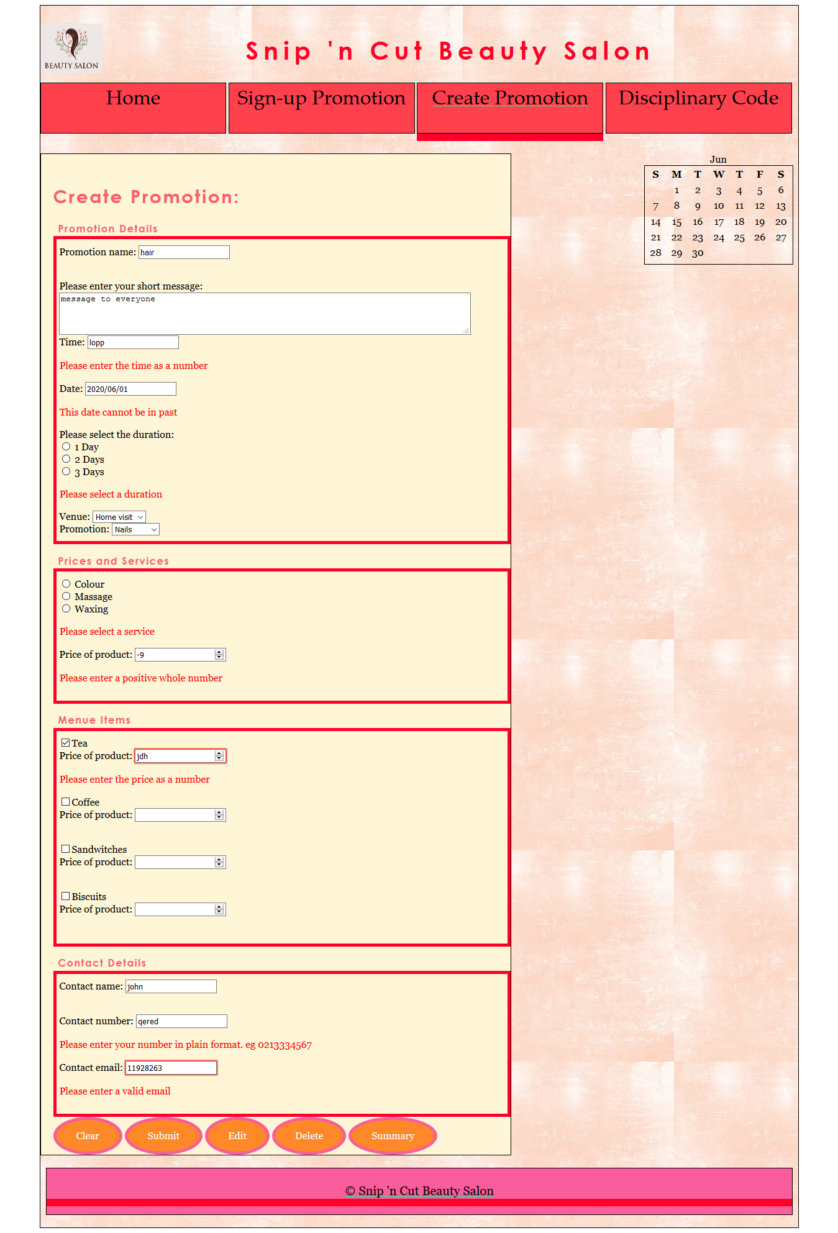

### Cookies

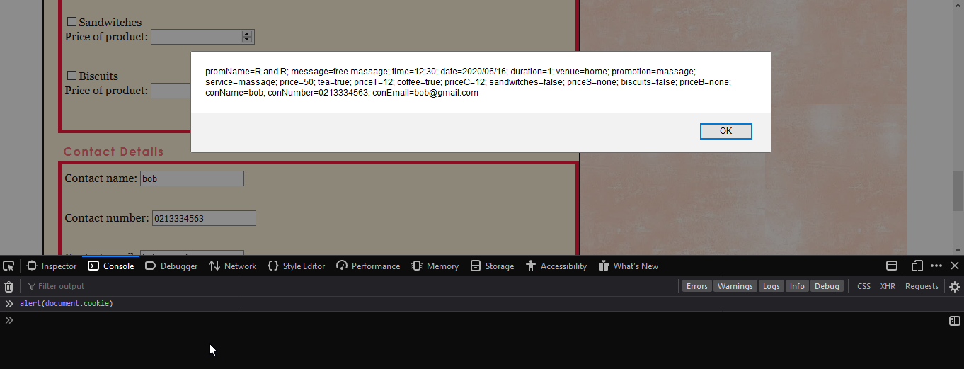

## Sign-up Page

### Validation

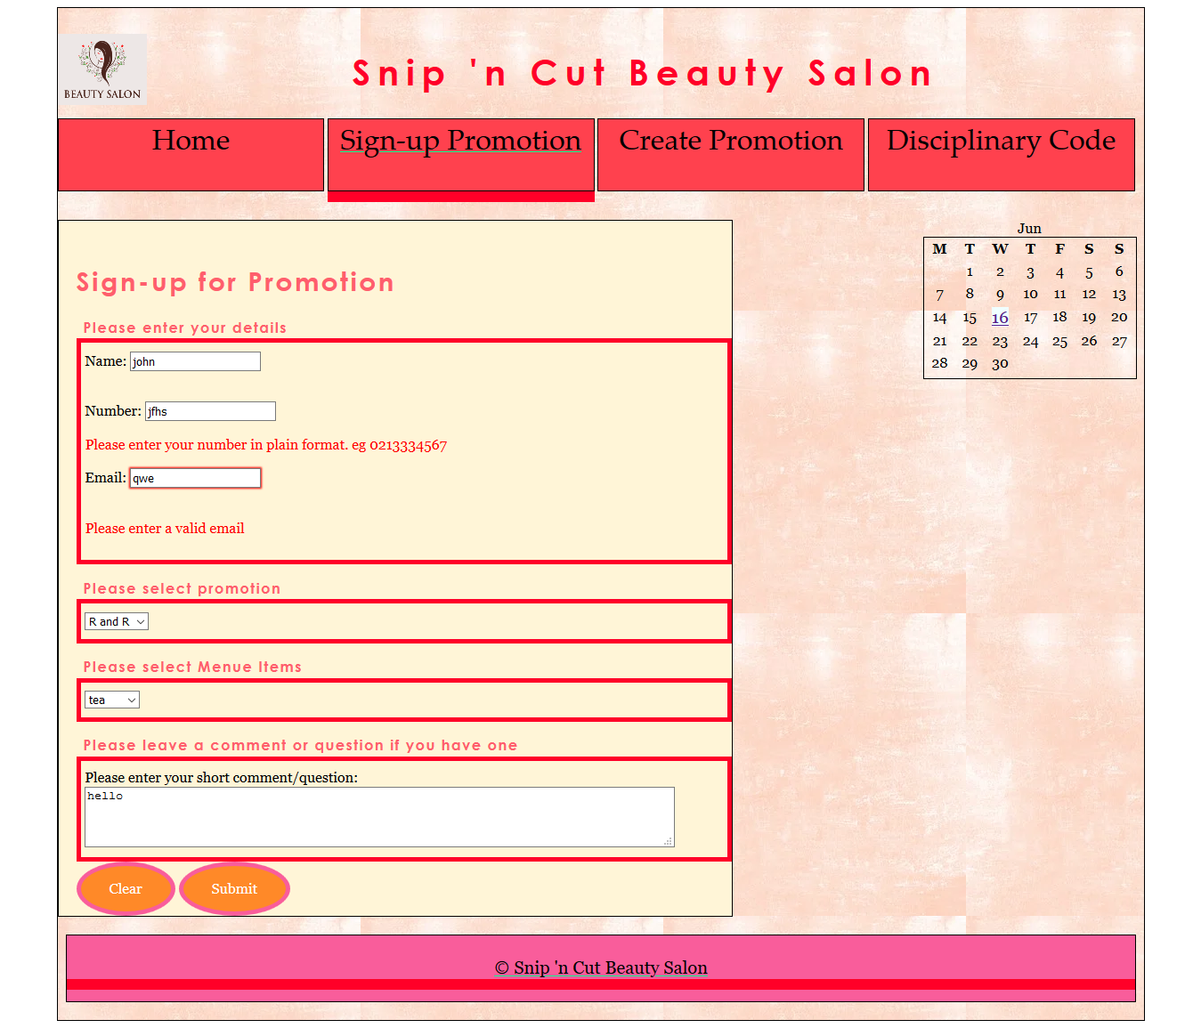

### Cookies

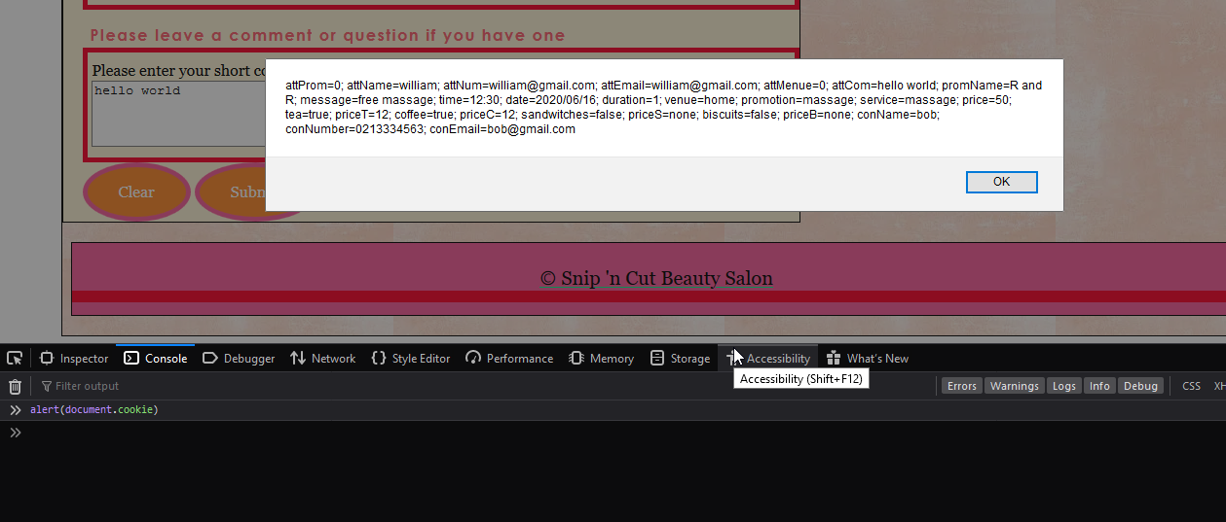

## Edit Promotion Page

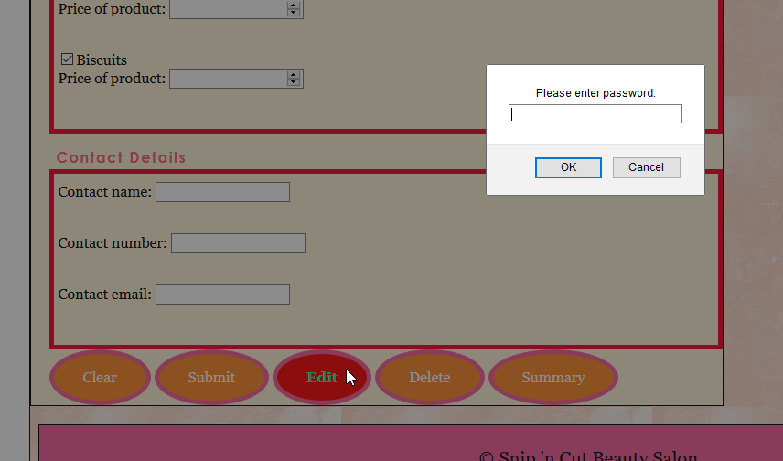

### Validation

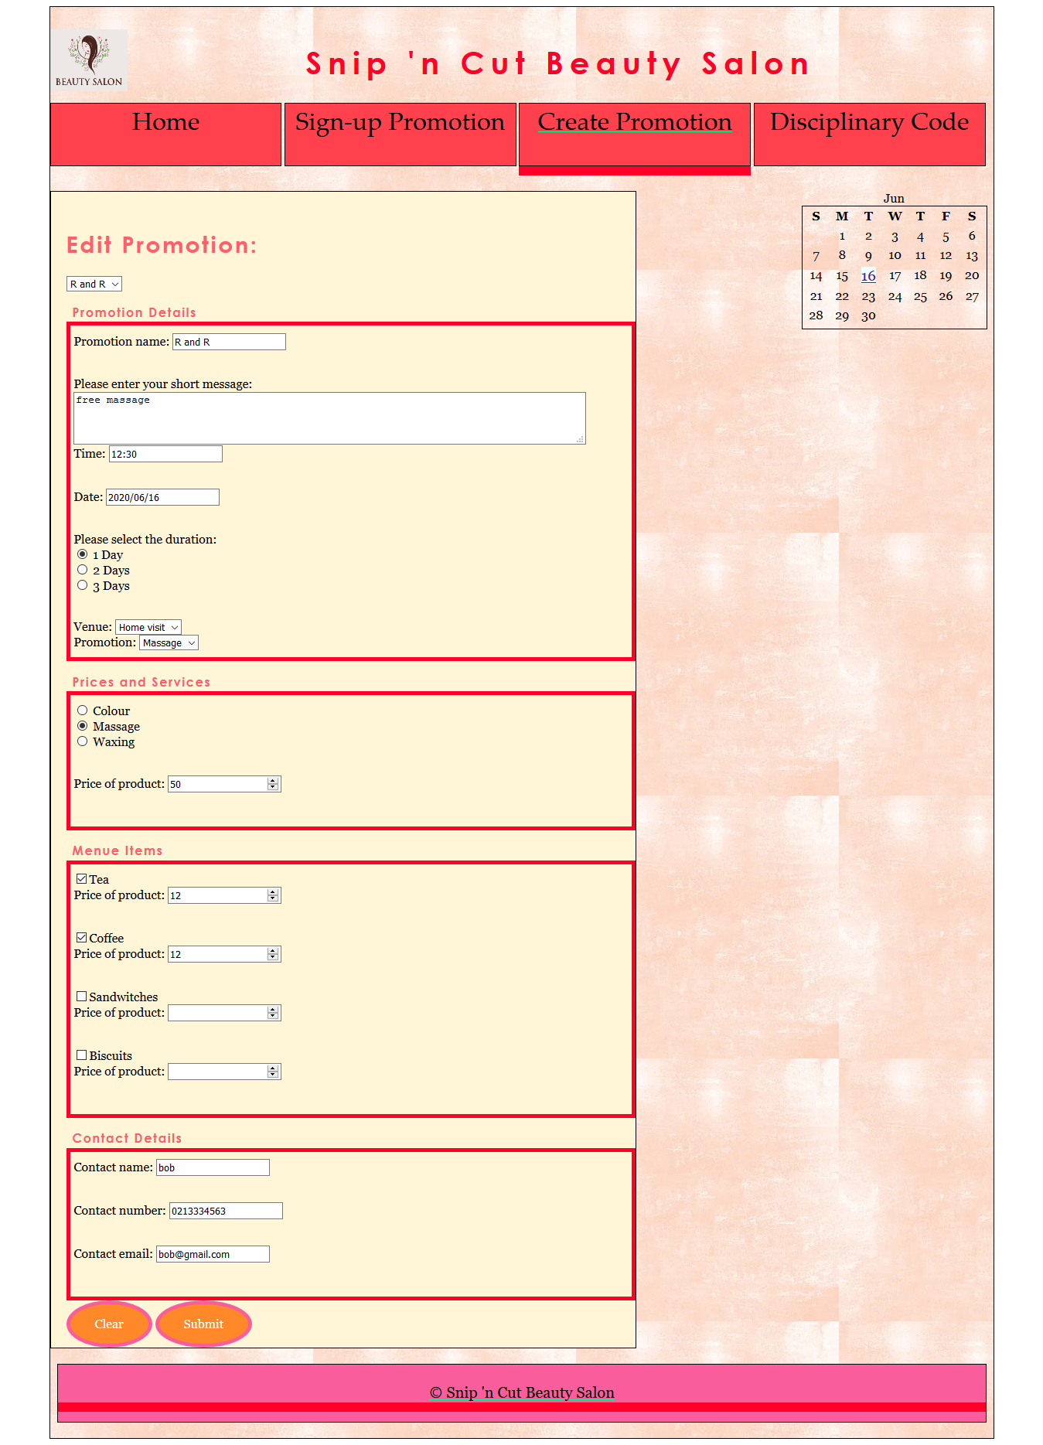

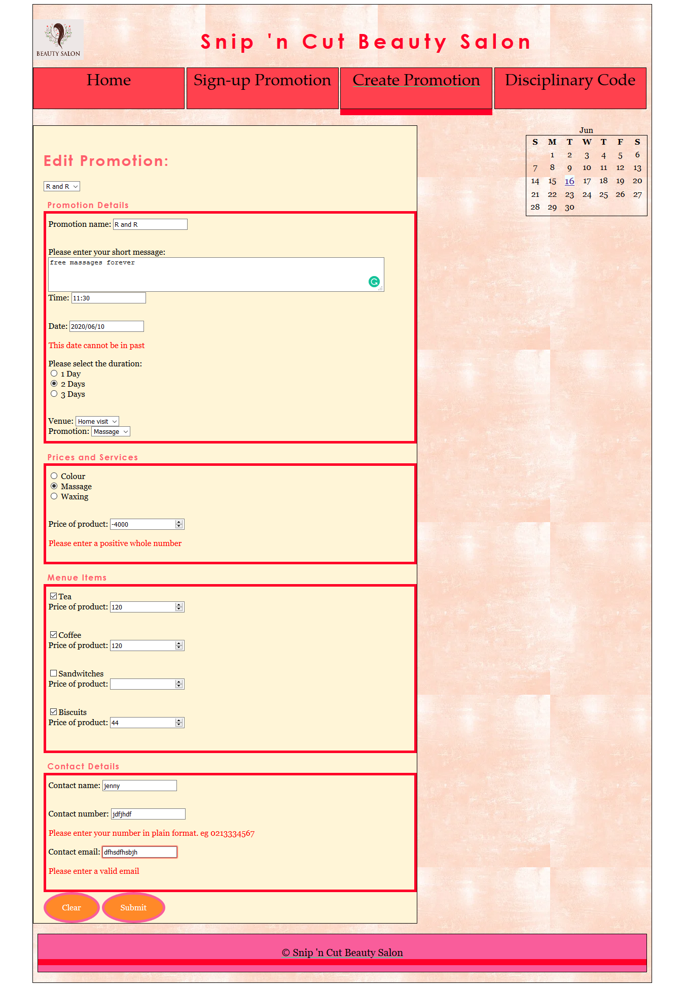

### Cookies

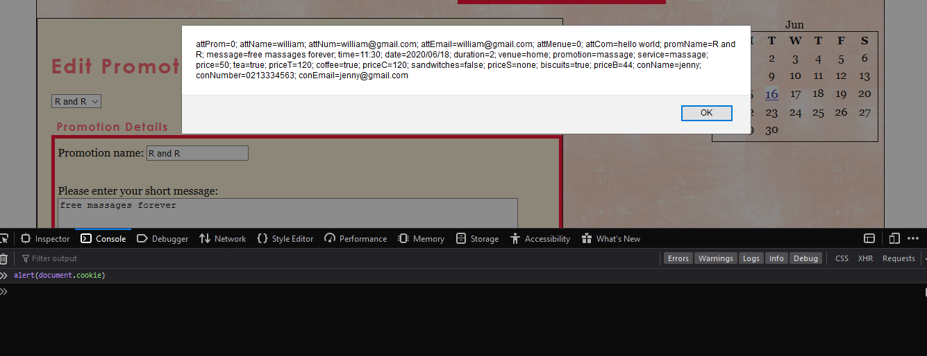

## Delete Promotion Page

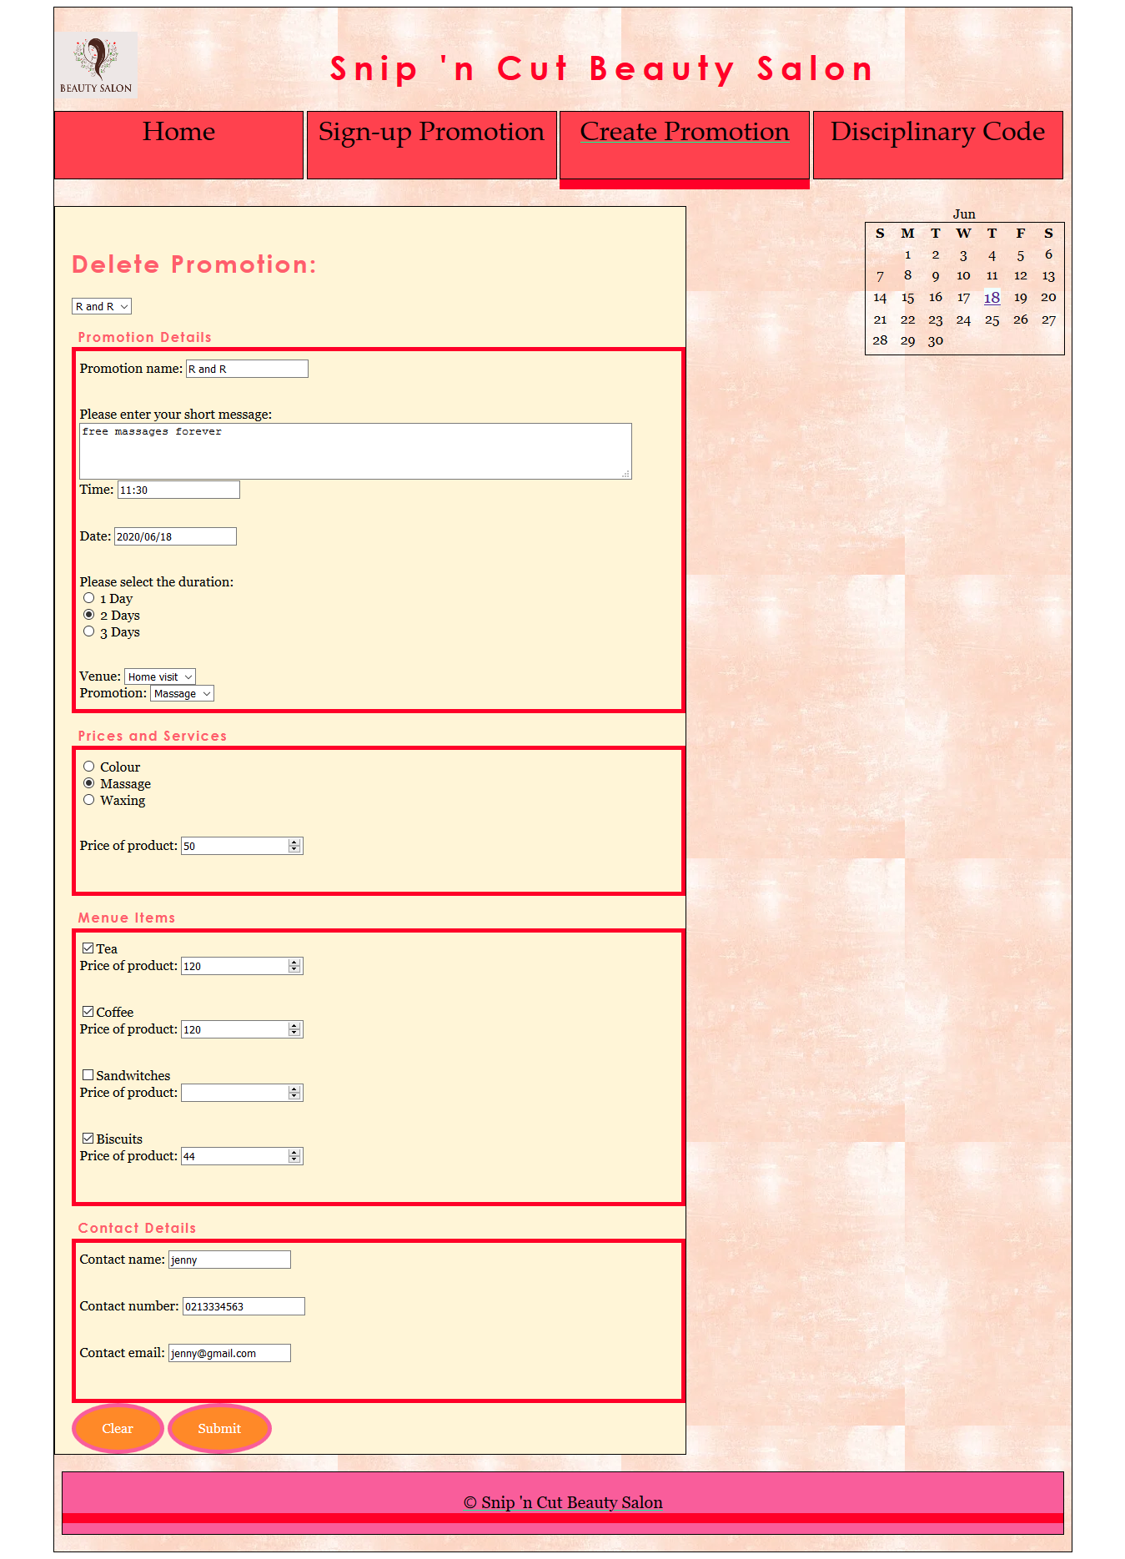

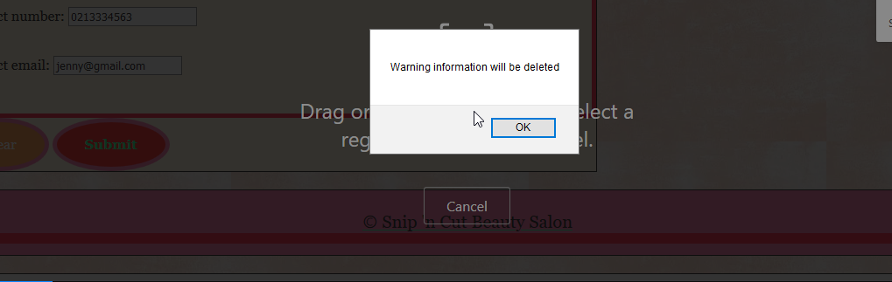

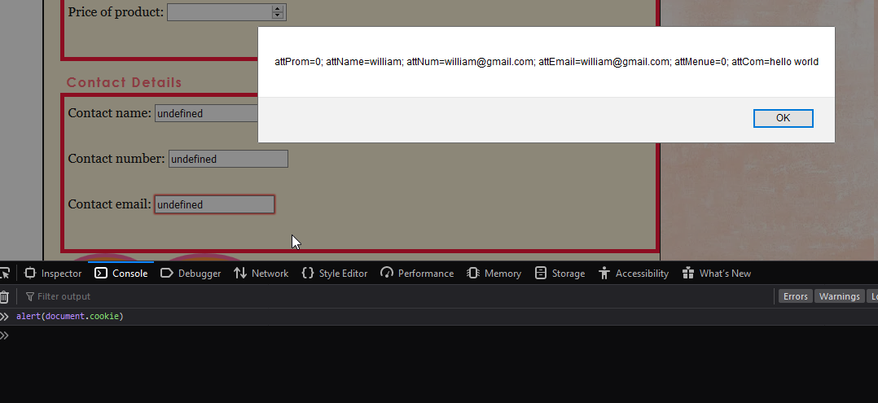

## Promotion 1 Summary Page

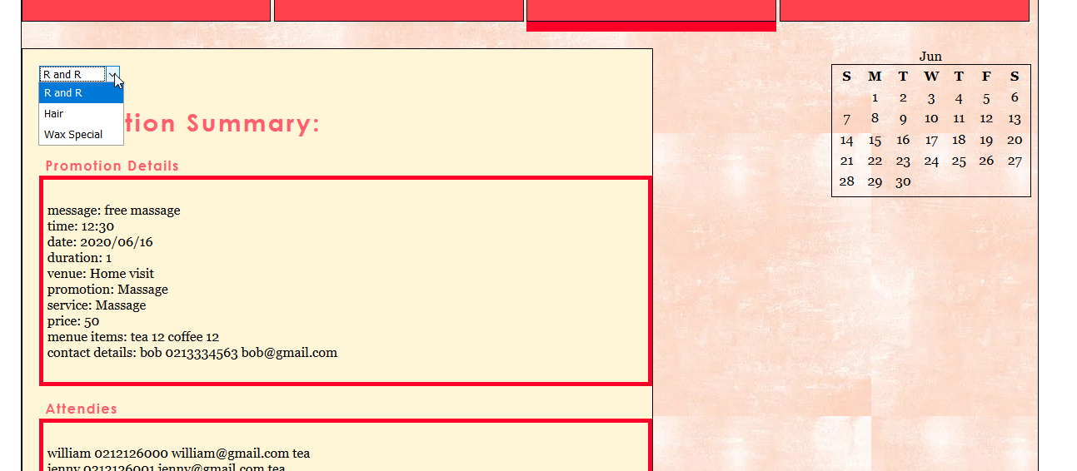

## Promotion 2 Summary Page

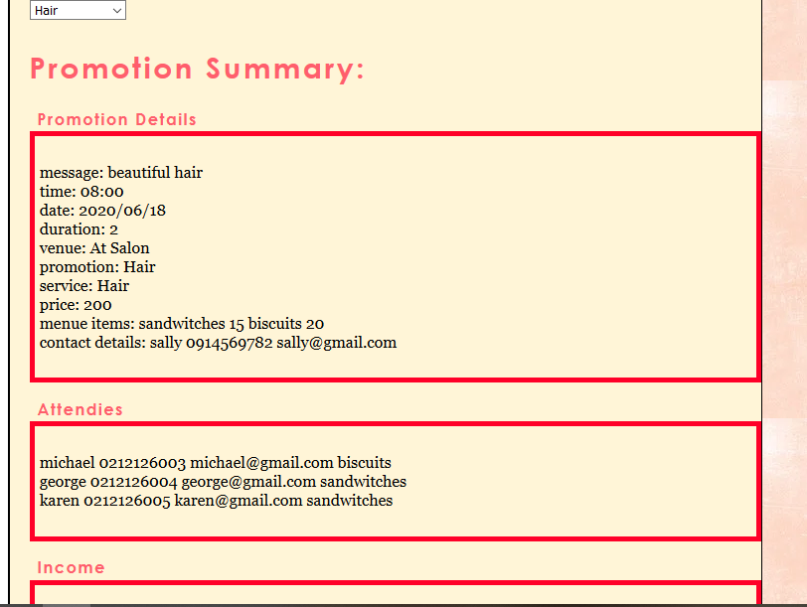

## Promotion 3 Summary Page

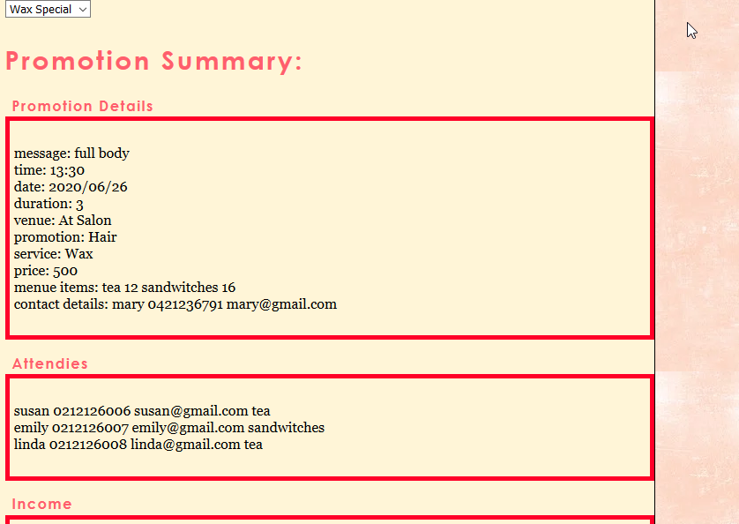

## Student’s Disciplinary Code Page

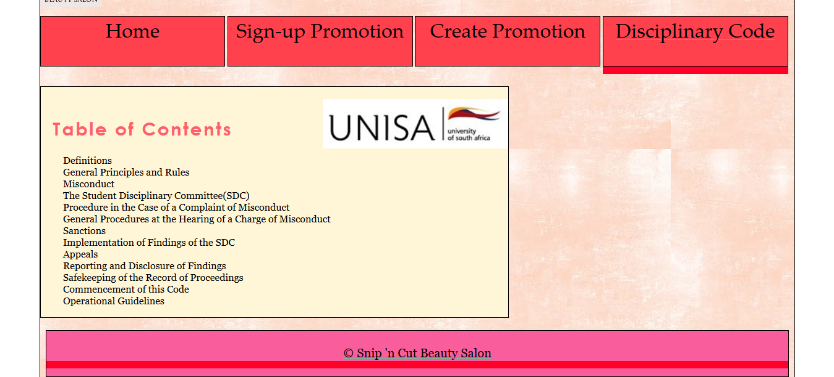

## Sub Page 1 – Student’s Disciplinary Code

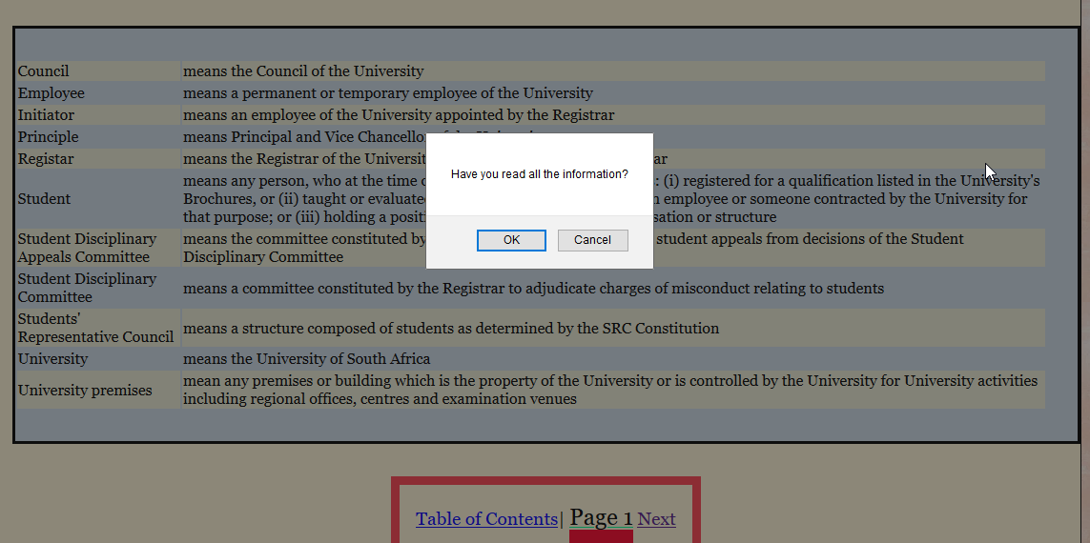

## Sub Page 6 – Student’s Disciplinary Code Validation

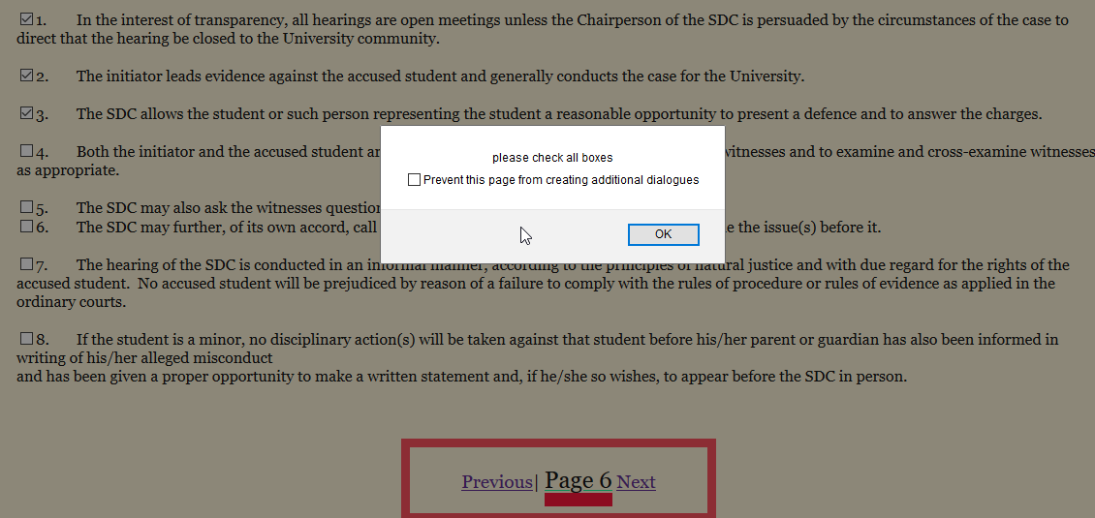

## Sub Page 9 – Student’s Disciplinary Code

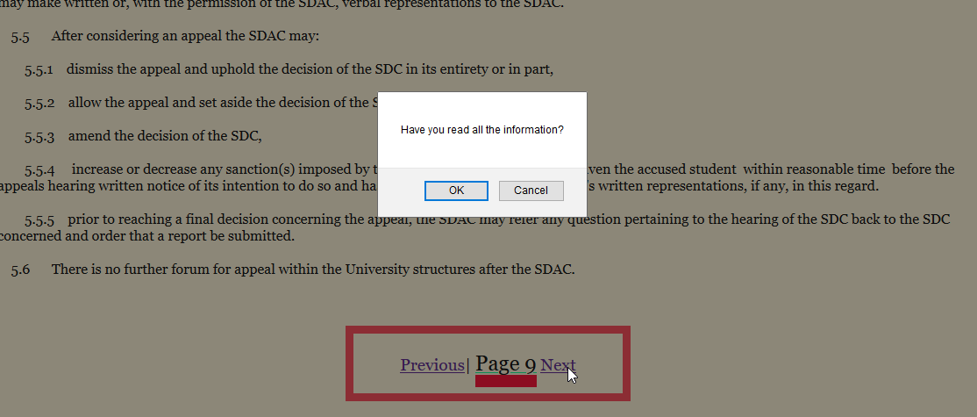

# Functions

1. //function to add values of selected check boxes and display total

function calcTotal() {

var itemTotal = 0;

var items = document.getElementsByTagName("input");

for (var i = 0; i < 5; i++) {

if (items[i].checked) {

itemTotal += (items[i].value * 1);

}

}

document.getElementById("total").innerHTML = "Your order total is $" + itemTotal + ".00";

}

//add backward compatible event listener to Submit button

var submitButton = document.getElementById("sButton");

if (submitButton.addEventListener) {

submitButton.addEventListener("click", calcTotal, false);

} else if (submitButton.attachEvent) {

submitButton.attachEvent("onclick", calcTotal);

}

# Explanation

This script consists of two main parts, an event listener and a function to calculate the total. The event listener has one variable that is set to button object of the html and is then given an onclick event. The event listener will run the function calcTotal. The calcTotal function, starts off by setting an empty local variable called itemTotal and assigns it a 0 value to indicate it is a numeric value. The second line, creates a variable called items that stores all the elements with a tag name “input”. This variable, items, is used to store the information of each checkbox in the html document, it stores this information in an indexed manner. The next part of the function is a for loop, the for loop creates a counter called, “I”, it allows the for loop to loop through each of the items using its index. This loop repeats the number of times there are checkboxes in the html document. Inside the for loop is the if statement that checks each item, if the item[i] is checked the itemTotal will be added too. The itemTotal will receive the value of the current items value, multiplied by 1 because of the cents, as we are dealing with money. The loop will continue to repeat 5 times and if an order item is checked its value will be added to total. Finally, the last line of the function, changes the text in the items element to “Your order total is $” plus the itemTotal that was just calculated